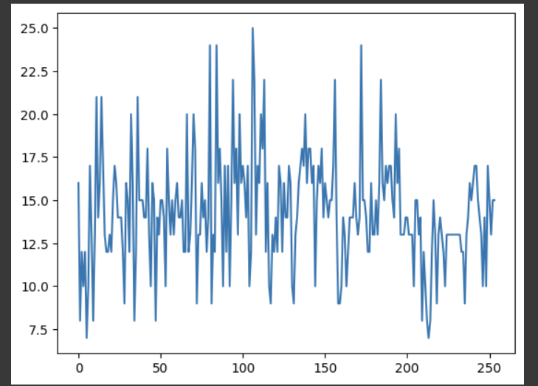

**Wind Speed Plot**

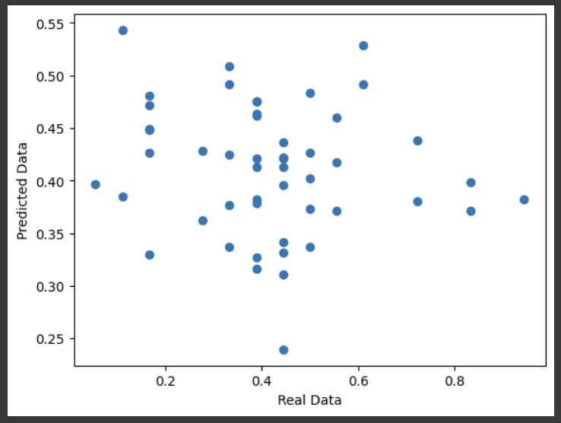

**Scatter Plot of Predictions**

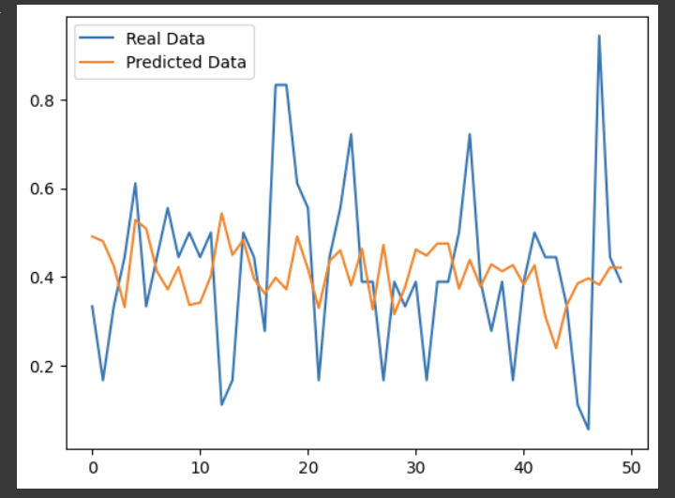

**Line Plot of Real vs. Predicted Data**